Database Modelling

Name of student

Name of professor

University

Course

Date

During software engineering, system analysis and design becomes a significant part of the development process. Usually, prototyping is key towards helping understand how the various parts and components of the system are going to be enhanced and achieved. These requirements vary from technical, software, network, hardware, security and skills force requirements, Bell &Thayer (1976).

Hardware application requirements deal with the physical parts of the technology being implemented. Suppose we are going to build and establish an ecommerce sales application to handle all the sales across the organization, the following hardware requirements may come in handy when solving this kind of problem. Bracket (1990), usually, the systems analysts are charged with the responsibilities of drafting and coming up with this kind of business case. Even though not so closely related, the hardware requirements help to achieve the final objective of the system. They are:

* Personal computer monitors (PCs)
* Central processing units (CPUs)
* Servers (Nginx, Centos, Apache)
* Routers
* Repeaters
* External storage drives

These hardware components work together to achieve the common goal of the organization. When writing computer programs, software come in handy to help the stakeholders design and implement the software requirement as the propriety at hand. Developing an efficient e-commerce applications will rely on the acquisition of the following software products:

* The correct programming IDE such as Pycharm, Vscode, Netbeans;
* Database management system
* The correct operating system such as Ubuntu, CentOs or Windows
* Firewalls
* Antivirus

Also, security needs of the application needs to be taken into account. The security requirements start from the hardware configuration. This can include the physical harnessing of the PC computers together, installation of intrusion detection systems in unauthorized rooms and locations. Other security measures include the installation of software such as firewalls, virtual private networks, proxy configurations and antivirus software. However, despite all these, security should be taken as policy issue rather than a software programming issue.

Finally, as part of the systems analysis and requirements gathering, a keen eye should be given to the staff partaking the project. Software engineers, database designers and engineers, testers, application designers come in handy and should not be ignored at all cost.

**Database design**

Database design is a concept that traditionally refers to the all the activities that gather around the establishment, classification and planning of the different components of the database. An e-commerce application for instance is more likely to be robust since the assumption here is that it will be handling a lot of data. Let’s observe the figure below:

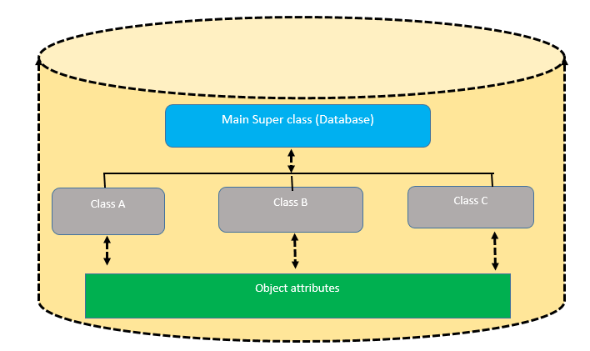

The main super class is the database that shall contain the other tables within the program. These tables are also called classes. Each class has its own attributes and variable definitions, Powell (2006). For the case of the retail winds application, a typical database application may look like below:

Database: opco_retailwinds

These database may have the following table classes:

1. Users
2. Customers
3. Categories
4. Products
5. Retailers
6. Agents
7. Location
8. Suppliers
9. Roles
10. Orders
11. Payments

These classes can be modelled into the below attributes:

|  |  |
| --- | --- |
| Class | Attribute |
| Users | -id; name; role_id; username;password; |
| Customers | -id;name;user_id;payment_id; |
| Categories | -id;c_name;prod_id;supplier_id;status; |
| Products | -id;prod_name;category_id;price;discount;status |
| Retailers | Id;retailer_name;status;product_id; |
| Agents | Id;name;product_id; |
| Location | -id;name;ip; |
| Suppliers | -id;name;category-id |
| Roles | -id;name;user_id |
| Orders | -id;name;price;product_id;tax;status; |
| Payments | -id;amount;status;customer_id;status |
|  |  |
|  |  |

**Relationships**

The above table’s class can be defined inside a class relationship involving the definite related keys together. From the illustration, it can be observed that the table classes have attributes that are illustrated in the above table. Some of these attributes are shared among member tables. Shared attributes are called foreign keys in this context and are used for referenceing contexts from other tables. This kind of illustration is very key especially when implementing the retail winds ecommerce application. Consider a case where a customer has bought different products from different categories and we would like to show this information in a single sales report/receipt. This is where table referencing comes in. Also, one class can have several of the other shared class attributes. For instance, it can be deduced that a user can purchase several products and so have multiple transactions. The ERD illustration looks like below:

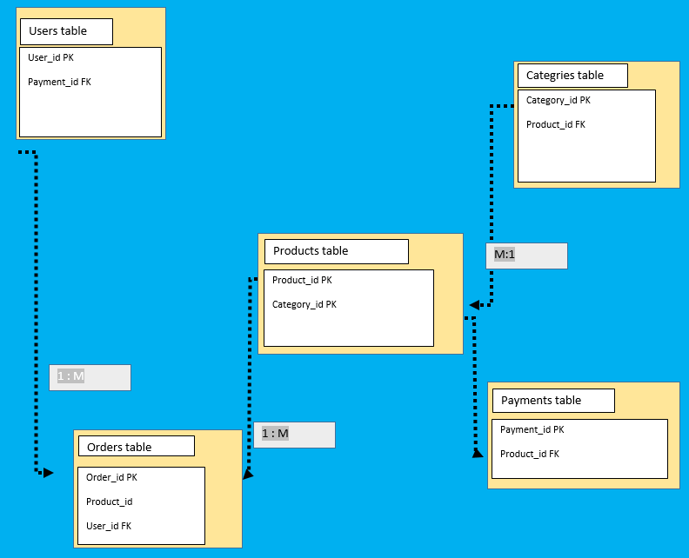

**References**

Bell, T. E., & Thayer, T. A. (1976, October). Software requirements: Are they really a problem?. In Proceedings of the 2nd international conference on Software engineering (pp. 61-68).

Brackett, J. W. (1990). Software requirements. CARNEGIE-MELLON UNIV PITTSBURGH PA SOFTWARE ENGINEERING INST.

Powell, G. (2006). Beginning database design. John Wiley & Sons.